Office Supplies Monitoring

Manual

3/6/2018

Inventory Exchange Center Inc.

* Input Username and Password to Login then click “Log-in” button

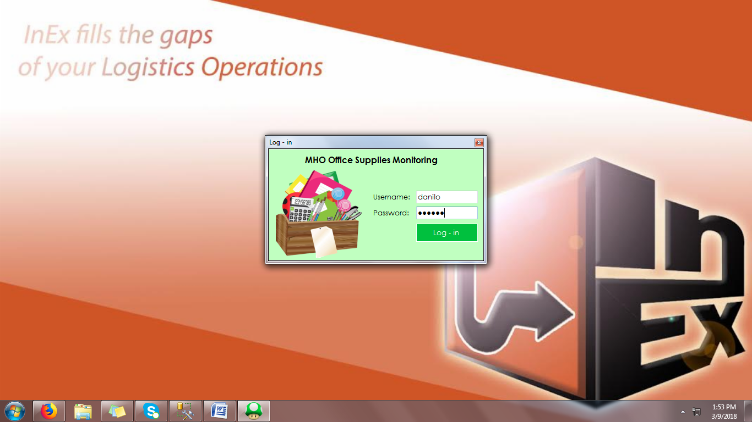

* Then “List of Office Supplies” window will now appear

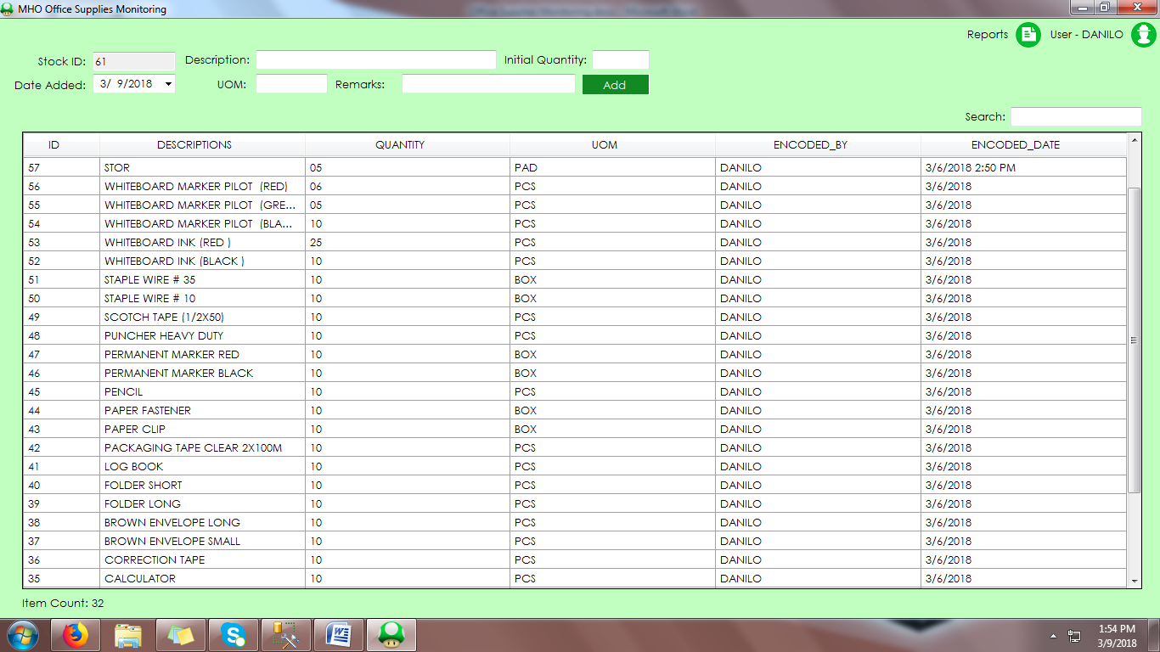

* To add new Item/Office Supply fill-up the ff. fields then click “Add” button
* To Add Quantity or Issue Office Supply double click the corresponding row

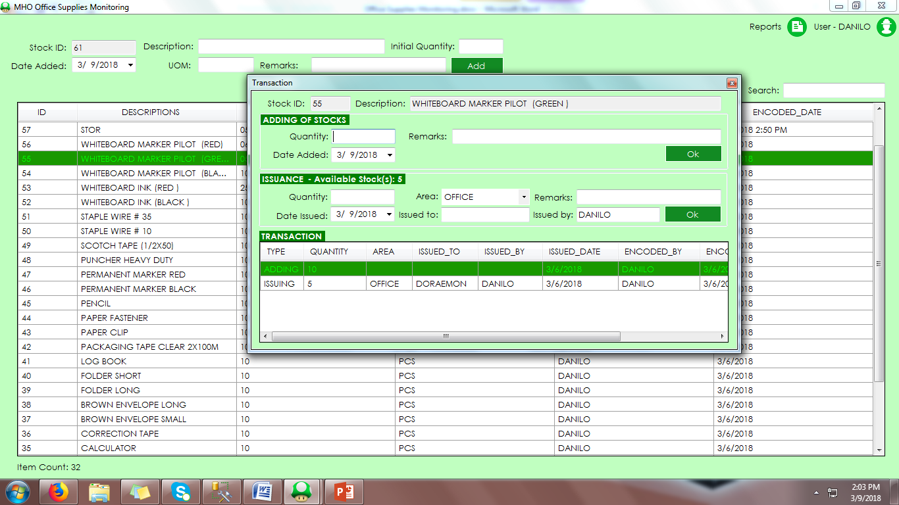

* To View all Received Stocks Click “Reports” then select “Stocks Added”

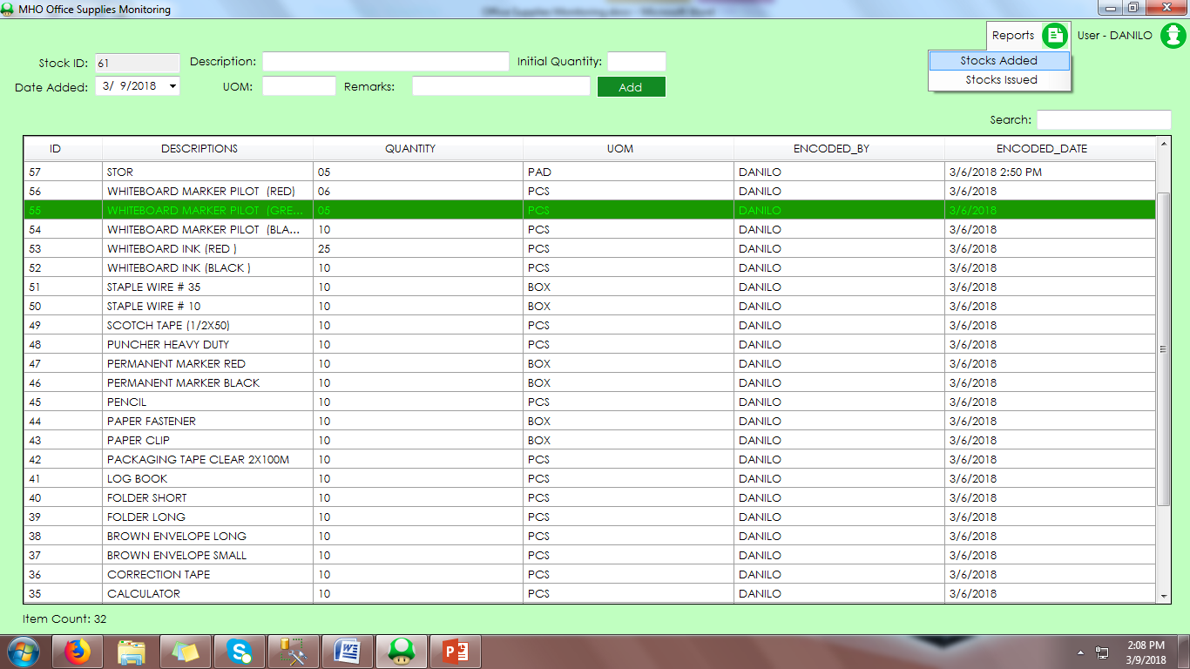

* Just Input the corresponding Dates then Click the “Go” button

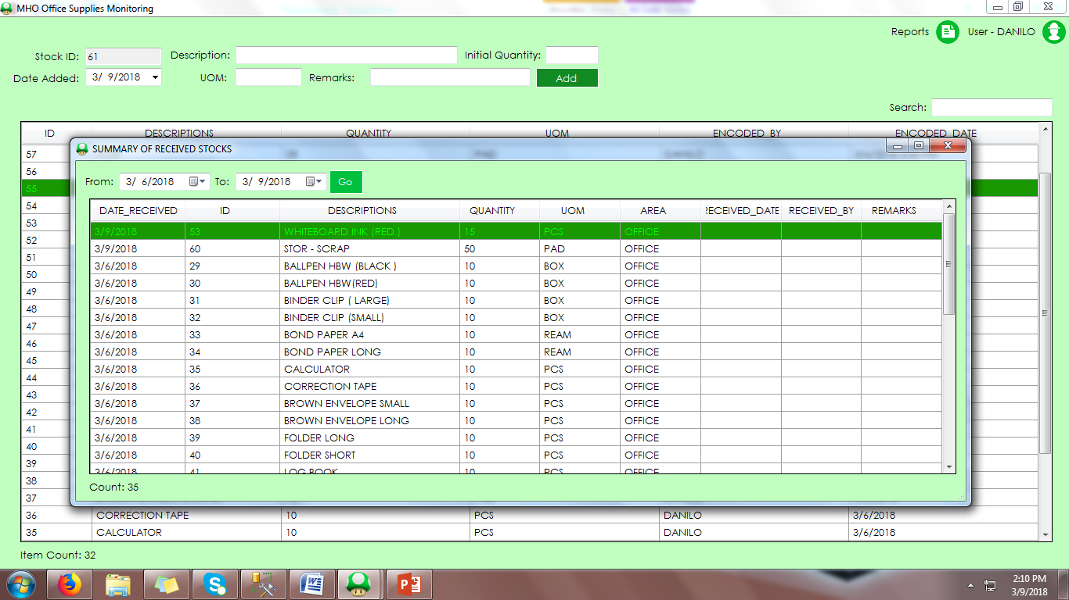

* To View all Issued Stocks Click “Reports” then select “Stocks Issued”

